Business Inteligence tool using AI

# Abstract

We have developed a proof-of-concept software tool using concepts from the business intelligence field to enable fast, reliable and reproducible quantitative analysis of mass spectrometry data. The software allows the user to search with any **keyword**, the tool searches, aggregates, stores and displays data. The user then interacts with these data structures with different format (Pictographic and as well in the Tabular) which the higher management able to understand the data.

# Solution Approach

On the business, to make any important decisions, the data is more important and understanding the data with usual format will cost on time. This tool, with any keywords the data will be fetched from different data sources irrespective of any sources (Web Api’s, Database, data files etc.)

The data will be consolidated from the search and provides in the pictorial format, so that the business gets the better understanding on the data and helps to make the quicker and smarter decision.

The tools is desigined with following tools and Technologies.

1. Microsoft Visual Studio.
2. Anaconda continuum tool.
3. Jupyter Notebook.
4. R-Kernel – Machine Learning.
5. D3.Js
6. Bootstrap.
7. R Studio

# Design Architecture

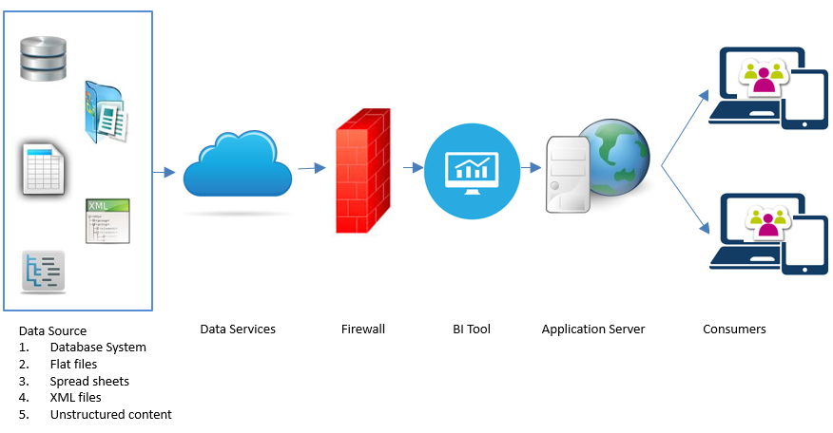

# Business Impact

1. Smarter Decision Making
2. Quicker Decision Making
3. Understanding of Data made simpler
4. Predictive data
5. Allows to add more data source
6. Allows to make more enhancement.
7. Data accuracy